Interchange Plus Pricing
Interchange is the set of costs that Visa and Mastercard charge to process debit and credit cards. What is interchange plus pricing? It is a unique pricing structure, also called pass through plus pricing, that allows businesses cost plus a set mark up on all of their credit card processing transactions. Below you will find a basic comparison between interchange plus and a typical tiered pricing structure.

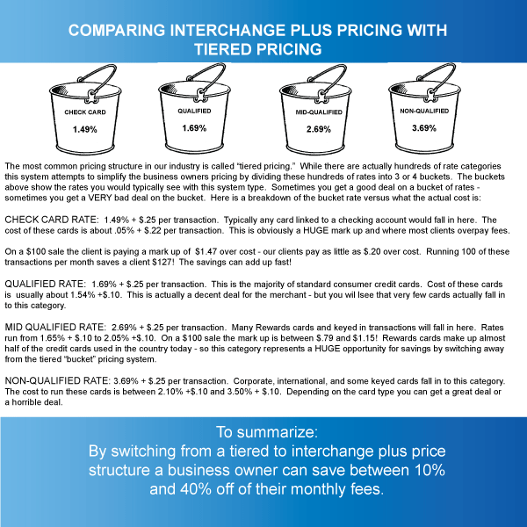

Interchange is set forth by Visa and Mastercard and despite what some sales people may tell you - it is not negotiable. Currently there are over 400 categories of interchange. They range from .05% + $.22 for debit cards up to 3.25% + $.10 per transaction for certain international or corporate cards. While businesses cannot negotiate the cost charged to accept credit cards - they can negotiate the mark up they pay over these costs. this is where an interchange plus pricing structure becomes a benefit to the business owner - as it allows for some clarity when it comes to understanding the mark up and what is negotiable.

How Does and Interchange plus pricing structure benefit you? This price structure ensures that the business owner will always get the best price on every credit card processed through their business. Typically businesses are set up to accept credit cards using a three tiered pricing structure. This takes the 400 categories and boils them down into 3 rates: qualified, mid- qualified, and non- qualified. While this may be simple to understand it will never offer the best pricing structure to the business owner. Interchange plus pricing will guarantee the best rate for every card run 100% of the time.

Mobile Wallets
EMV
NFC
Electronic Signature Capture
Free Credit Card Terminals
INDUSTRY UPDATES:
The Durbin Amendment
FANF
INDUSTRY KNOWLEDGE:
Interchange Plus Pricing

